Project Plan

For

Tiny Coders

Team members:

Erika Valle-Baird

Domeniko Kondra

Mohammed Khoshkhoiyazdi

Madison Bilko

Collin Cavanaugh

Appendices: <Appendix 1>

**1 Introduction ……………………………………………………………………….……3**

1.1 Project scope …………………………………………………………………………..3

1.2 Major software functions ………………………………………………………………4

1.3 Performance/Behavior issues ………………………………………….………...…….7

1.4 Management and technical constraints ………………………………….…...………..8

**2 Project Estimates…………………………………………………………..…….……..8**

2.1 Historical data used for estimates ………………………………………..…..……….8

2.2 Estimation techniques applied and results …………………………………………….8

2.2.1 Estimation technique *m …………………………………………………………….…..…..*8

2.2.2 Estimate for technique *m…………………………………………………….………………*8

2.3 Reconciled Estimate…………………………………………………………………..19

2.4 Project Resources ……………………………………………………….…………….19

**3 Risk Management …………………………………………………………….………..20**

3.1 Project Risks……………………………………………………………………………20

3.2 Risk Table……………………………………………………………………………….20

**4 Project Schedule …………………………………………………………………………26**

4.1 Project task set ………………………………………………………………………….27

4.2 Functional decomposition ……………………………………………………..……….28

4.3 Task network ………………………………………………………………..…………..28

4.4 Timeline chart …………………………………………………………….…………….29

**5 Staff Organization …………………………………………………………………….….29**

5.1 Team structure ……………………………………………………………..……………31

5.2 Management reporting and communication …………………………………………….32

1. INTRODUCTION

Dream Destination Getaways is an LLC providing users with the vacation planning ensuring the lowest possible prices and enabling them to travel to destinations previously believed to be outside their price ranges. Dream Destination Getaway’s website will be developed via a complete software project management plan for creating and maintaining a website for the lowest travel fares.  The destination does not have to be known, however both depart and return dates have to be specified per user.  Once a flight has been added to the user’s shopping cart, the user will have the ability to decide if a hotel and rental car are necessary, and have the ability to add such items in their shopping cart.

1.1 Project Scope

1.1.1 Scope Statement:

The project will start once the main work on the project plan is finished.

Firstly, the team will analyze tasks and produce required documents such as estimates, a list of risks and milestone chart. Based on these documents the team will be able to agree on the dates for the project.

1.1.2 Assumption:

* The project will be done by all the members of the team.
* The team needs two months to finish the project.
* Materials will arrive as planned within the project schedule.

1.1.3 Constrains:

* The software needs to be finished before the due date.
* There is a small chance that team members' personal schedule might affect the tasks due dates.

1.2 Major Software Functions

User Functionality:

* Registration
  + Name (first, last)
  + Address (street name & number, city, state, zip code)
  + Email address
  + Confirm email address
  + Credit card info (number, type, expiration date, billing address)
  + Create login (see below)
* Create Login
  + Username
  + Password
  + Confirm password
  + Security question & answer
* Login to Account
  + Username
  + Password
  + Forgot username or password (answer security question)
* Search
  + From city
  + Departure date
  + Return date
  + Specific destination
  + Continent specific destination
  + Open to any destinations
* Flight info
  + Price
  + Availability
* Add to shopping cart
  + Display all flights in the shopping cart
  + Display destination specific available hotels
  + Display destination specific available car rentals
  + Calculate total balance (see below)
* Balance Calculator
  + Adds total price of flights, hotel reservations, and car rentals in shopping cart
  + Displays total balance
* Delete from Shopping Cart
  + Removes selected flights, hotel reservation, and car rental from shopping cart
  + Calculates balance
* Purchase
  + Displays contents of shopping cart of each flight, hotel reservation, and car rental
  + Calculates & displays balance total
  + Confirm purchase
  + Processes purchase (charges credit card)
  + Displays confirmation number
  + Displays package options
* Update Account Info
  + Displays users account info (registration info)
  + Allows user to edit any of the info (name, address, email address, billing address, credit card type, number, expiration date, & password)
  + Confirm changes
* Contact Us
  + Displays company’s address
  + Displays company’s telephone number
  + Displays company’s email address
  + Displays company’s mission
  + Displays about us information
* Help
  + Explains how to use website
  + Explains how to use listed functions above
* Account Logout
  + Exits user account

Management Functionality:

* Administration Account
  + Login info (username & passwords)
  + Update account info
  + Delete account
* Add Flight
  + Flight Number
  + Departure
  + Destination
  + Hotel
  + Car Rental
* Update Account
  + Name
  + Credit Card Type
  + Credit Card Number
  + Address
  + Billing Address
* Search Flight
  + Flight name
  + Synchronize flight, hotel, and car rental information from travel web sites
* Search Hotels and Car Reservation Options
  + Hotel name
  + Type of room
  + Hotel Price
  + Car name
  + Car price
  + Type of car
* Purchase Flight
  + Flight Number
  + Departure Date
  + Additional options
  + Quantity
  + Transmit order

1.3 Performance/Behavior Issues

* Internet must be working properly
* Navigation through website and processing of functions must be fast
  + Time it takes to go to next screen
  + Time it takes to process orders, credit card transactions
* User interface must be simple and easy to use & understand

1.4 Management and Technical Constraints

* Small staff size
* Inexperience of staff
* Internet issues – up and running
* Availability of inventory from distributors

**2.0 Project Estimation**

* **Introduction**

This section provides the estimated cost, effort and time for the Dream Destinations Getaways project. In order to estimate our project cost, timeline, and man power, we are decomposing the problem into size and function points. After which we will compare answers to ensure accuracy in our estimates.

* **2.1 Historical data used for estimates**

Project effort and time will be estimated using the COCOMO estimation model. The software Dream Destination has an average complexity, due to the backgrounds of our programmers and small team size, along with a stable environment. These characteristics allow us to classify our mode under intermediate COCOMO model, providing us with the formulas to determine effort, time, and total costs of the project.

* **2.2 Estimation Techniques applied and results**

The total cost will be determined by using the lines of code technique. This required to calculated the estimated line of code for each function and then to add them up and find the total lines of code. Using this information we calculate the estimate for effort, time and cost.

Second technique we are using is called Process based. In this technique we only multiply the average burdened labor rate by the effort found in the COCOMO model.

The third technique is called Function Point Based Estimation. Here we need to find the value adjustment factor by adding the values for each of the 14 factors. Once we found that we also need to calculate the total count and then plug it in a formula and find the effort time and cost estimate.

The formula for organic mode projects in COCOMO intermediate type is:

Effort =(3.0 * (KDSI)^1.12) * EAX

where EAX = Effort Adjustment Factor

KDSI= number of delivered source instructions in thousands.

Time =2.5 * (E)^0.35

where E= effort calculated above.

The intermediate type estimates the software development effort by using 15 cost drivers variables. The four areas for drivers are: product itself, computer, personnel and project itself.

|  |  |  |  |
| --- | --- | --- | --- |
| Product Attributes | Computer Attributes | Personnel Attributes | Project Attributes |
| RELY:  Required Software Reliability | TIME:  Execution Time Constraint | ACAP:  Analyst Capability | MODP:  Modern Programming Practices |
| DATA:  Data Base Size | STOR:  Main Storage Constraint | AEXP:  Applications Experience | TOOL:  Use of Software Tools |
| CPLX:  Software Product Complexity | VIRT:  Virtual Machine Volatility | PCAP:  Programmer Capability | SCED:  Required Development Schedule |
|  | TURN:  Computer Turnaround Time | VEXP:  Virtual Machine Experience |  |
|  |  | LEXP:  Programming Language Experience |  |

The Adjustments factors are listed below:

|  |  |  |  |  |  |  |
| --- | --- | --- | --- | --- | --- | --- |
| **Cost Driver** | **Very Low** | **Low** | **Nominal** | **High** | **Very High** | **Extra High** |
| **Product Complexity** | 0.70 | 0.85 | 1.00 | 1.15 | 1.30 | 1.65 |

Table with Effort Multipliers

|  |  |  |
| --- | --- | --- |
| **Cost Drivers Variables** | **Ranges depending on rating above; Low to High** | |
| RELY | 0.80 | 1.30 |
| DATA | 1.00 | 1.15 |
| CPLX | 0.70 | 1.65 |
| TIME | 1.00 | 1.55 |
| STOR | 1.00 | 1.50 |
| VIRT | 0.85 | 1.15 |
| TURN | 0.85 | 1.20 |
| ACAP | 0.70 | 1.15 |
| AEXP | 0.80 | 1.10 |
| PCAP | 0.70 | 1.30 |
| VEXP | 0.85 | 1.20 |
| LEXP | 0.85 | 1.20 |
| MODP | 0.80 | 1.20 |
| TOOL | 0.85 | 1.30 |
| SCED | 1.1 | 1.25 |

|  |  |  |
| --- | --- | --- |
| Cost Driver Variables | Effort | Rating |
| RELY | 1.00 | Nominal |
| DATA | 1.00 | Nominal |
| CPLX | 0.85 | Low |
| TIME | 1.00 | Nominal |
| STOR | 1.00 | Nominal |
| VIRT | 0.87 | Low |
| TURN | 0.85 | Low |
| ACAP | 1.00 | Nominal |
| AEXP | 1.25 | Low |
| PCAP | 1.00 | Nominal |
| VEXP | 0.95 | High |
| LEXP | 0.90 | High |
| MODP | 0.90 | High |
| TOOL | 1.00 | Nominal |
| SCED | 1.00 | Nominal |

We calculated EAX by multiplying the results. **EAX= 0.67**

**LOC-Based Estimation**

1. Estimation with LOC-Based Estimation

Weighting Factors

External Inputs: 4

External Outputs: 8

External Inquires: 9

Internal Logical Files: 4

Using C++ language for the LOC/FP Estimate = 64

|  |  |  |  |  |
| --- | --- | --- | --- | --- |
| Function | FP | Weighting  Factor | LOC/FP | Total LOC |
| Account Registration | EI, ILF | 4 + 4 | 64 | 512 |
| Update Account Information | EI | 4 | 64 | 256 |
| Add an Item | EI, ILF | 4 + 4 | 64 | 512 |
| Update Item | EI | 4 | 64 | 256 |
| Balance Calculator | EO | 8 | 64 | 512 |
| Contact Us | EO | 8 | 64 | 512 |
| Help | EO | 8 | 64 | 512 |
| Account Login | EQ | 9 | 64 | 576 |
| Account Logout | EQ | 9 | 64 | 576 |
| Add to Shopping Cart | EO , EQ, ILF | 8 + 4 + 9 | 64 | 1344 |
| Delete from Shopping Cart | EQ, ILF | 8 + 4 | 64 | 768 |
| Search | EO, EQ | 8 + 9 | 64 | 1088 |
| Checkout | EO , EQ | 8 + 9 | 64 | 1088 |
| Delete Item | EQ | 9 | 64 | 576 |
| Generate a Receipt | EO, ILF | 8 + 4 | 64 | 768 |
| View Previous Transactions | EO, EQ, ILF | 8 + 9 + 4 | 64 | 1344 |
| LOC TOTAL |  |  |  | 11200 |

**Total of lines of code = 11200** 

**KDSI = 11.2**

Using LOC and EAX, we can calculate the Effort and Time using formulas:

Effort = (3.0 * (KDSI)^1.12) * EAX

= (3.0 * (**11.2**)^1.12) * 0.67

= 30.08  **PM**

**Effort =** 30.08**PM**

Time = 2.5 * (Effort)^0.35

= 2.5 * (30.08)^0.35

= 8.23 months

**Time = 8 months**

Productivity = Total Lines of Code / Effort (PM)

= 11200 LOC / 30.08 PM

= 372.34 LOC/PM

Average Staffing = Effort / Time

= 30.08/8

= 3.76 Persons

= 4 Persons

Cost per LOC = Burdened Labor Rate / Productivity

= $12800/372.34

= $34.38/LOC

Average burdened labor rate: Using our staff estimate of an average of 4 staff members, assuming they all work full-time, with a pay rate of $20 an hour.

Average burdened labor rate = 4 Staff Members * 40 hours/week * 4 weeks/month * $20/hour

= $12800/month

Using this information we can estimate total cost via the formula

total cost = Cost/LOC * Total LOC

= $34.38 Cost/LOC * 11200 Total LOC

= $385,056

**Function Point Based Estimation**

For this estimation we need 14 value adjustments factors and for each one of them we need to rate it between 0-5, where 0 is not needed and 5 is absolutely must.

|  |  |
| --- | --- |
| **Factor** | **Value** |
| Backup required | 5 |
| Data communication | 5 |
| Distributed processing | 4 |
| Optimal performance | 3 |
| Heavily used operating system | 3 |
| Online data security | 5 |
| Multiple screens | 2 |
| Online master file update | 4 |
| Complex inputs, Queries, Outputs | 3 |
| Complex internal processing | 3 |
| Reusable code | 2 |
| Conversion/ installation in design | 1 |
| Multiple user sites | 1 |
| Ease of use | 5 |
| **Value Adjustment factor** | **44** |

FP = CT * (0.65 + (0.01 x ΣFi))

Where

CT = unadjusted function points from table

ΣFi = total score from questionnaire14 complexity adjustment factors with values 0 to 5

**Domain**

|  |  |  |  |  |
| --- | --- | --- | --- | --- |
| External Inputs (EI) | External Outputs (EO) | External Inquiries (EQ) | Internal Logical Files (ILF) | External Interface Files (EIF) |
| Account Registration | Balance Calculator | Login to Account | Account Information | None |
| Update Account Information | Search Results | Logout of Account | Item Information |  |
| Add an Item | Shopping Cart | Add Item to Shopping Cart | Shopping Cart |  |
| Update an Item | Checkout | Delete Item from Shopping Cart | Past Transactions |  |
|  | Contact Us | Flight Search |  |  |
|  | Help | Shopping Cart Checkout |  |  |
|  | Generate a Receipt | Add Package to Shopping Cart |  |  |
|  | View Past Transactions | Generate Receipt |  |  |
|  |  | View Previous Transactions |  |  |

**Function Points**

|  |  |  |  |
| --- | --- | --- | --- |
| Information Domain Value | Count | Weighting Factor | Total |
| External Input (EI) | 4 | 5 | 20 |
| External Output (EO) | 8 | 6 | 48 |
| External Inquires (EI) | 9 | 5 | 45 |
| Internal Logical Files (ILF) | 4 | 8 | 32 |
| External Interface Files(EIF) | 0 | 0 | 0 |
| Count Total |  |  | 145 |

Count Total (CT) = 145

ΣFi = 44

FP = CT * (0.65 + 0.01 x ΣFi)

FP = 145 * (0.65 + (0.01 * 44))

FP = 158.05

Average productivity = FP / Effort

= 158.05/30.08

= 5.25 FP/PM

Burdened labor rate is $12800/month.

Cost per FP is approximately = Burdened Labor Rate/Average productivity

= $12800/5.25

= $2438.1/FP

The total estimated project cost = Cost/FP * FP

= $2438.1 * 158.05

= $385341.7

The total estimated effort = FP/Productivity

= 158.05/5.25

= 30.10 person-month.

The total estimated duration = effort/4 weeks/month

= 30.10/4

= 7.53 months

**2.3 Reconciled Estimate**

Final Estimated Cost: ($385,056 + $385,341.7) / 2

= $385,198.85

Final Estimated Effort: (30.08 + 30.10) / 2

= 30.09 PM

Final Estimated Duration: (8 + 7.53) / 2

= 7.77 Months

**2.4 Project Resource**

For this project we will be making use of our team of 5 programmers, with varying experience. Hardware for this project will be both personal computers and the university computer Laboratory. Software employed may vary from open-source solutions to MySQL and PHP. Tools utilized for this project include Eclipse for IDE, Netbeans, and Visual Studio.

**3.0 Risk Management**

**3.1 Project risks:**

PR – Project Risk

TR – Technical Risk

BR – Business Risk

* **3.2 Risk Table:**

Each project risk here is described and discussed with possible causes of the risk occurring.

|  |  |  |  |  |  |  |  |
| --- | --- | --- | --- | --- | --- | --- | --- |
| Risk Title | Likelihood | Impact | Cost | Priority | Mitigation Plan | Assigned | Target Date |
| Personnel Shortfalls | 6 | 8 | 8 | 120 | Regularly scheduled meetings with clear expectations voiced | EB | Cont. |
| Developing the wrong software functions | 3 | 5 | 6 | 288 | Subject system to regular tests. | DK | Cont. |
| Developing the wrong user interface | 3 | 5 | 6 | 288 | Subject system to regular tests. | MK | Cont. |
| Customer Data Security | 5 | 9 | 9 | 108 | Frequent stress tests | MB | Cont. |
| Technology will not meet exceptions | 5 | 3 | 4 | 192 | Monitor database activity. | CC | Cont. |
| Poor Comments in code | 2 | 2 | 3 | 189 | Try to resolve by using standard commenting procedures. | DK | Cont. |
| Deviation from software engineering standards | 3 | 4 | 4 | 224 | Ensure software development methods are agreed upon in advance. | EB | Cont. |

|  |  |  |  |  |
| --- | --- | --- | --- | --- |
| **Risk Information Sheet** | | | | |
| **Risk Type**:  PR | **Date**:  Cont. | **Probability**:  60% | | **Impact**:  8 |
| **Description:**  Personnel Shortfalls | | | | |
| **Impact**:  The project may take longer than anticipated, leading to possible missed deadlines. | | | | |
| **Mitigation/monitoring**:  Regularly scheduled meetings with clear expectations voiced. | | | | |
| **Management/contingency plan/trigger**:  Problem identification coupled with development workarounds. | | | | |
| **Current status**: In Progress | | | | |
| **Originator**: Erika Valle-Baird | | | **Assigned**: Erika Valle-Baird | |

|  |  |  |  |  |
| --- | --- | --- | --- | --- |
| **Risk Information Sheet** | | | | |
| **Risk Type**: TR | **Date**:  Cont. | **Probability**:  30% | | **Impact**:  5 |
| **Description**:  Developing the wrong software functions | | | | |
| **Impact**:  Website and database integration issues. | | | | |
| **Mitigation**/**monitoring**:  Subject system to regular tests. | | | | |
| **Management**/**contingency** **plan**/**trigger**:  Identify issues and develop a workaround. Change functions to be compatible with tools. | | | | |
| **Current** **status**: In Progress | | | | |
| **Originator**: Erika Valle-Baird | | | **Assigned**: Domeniko Kondra | |

|  |  |  |  |  |
| --- | --- | --- | --- | --- |
| **Risk Information Sheet** | | | | |
| **Risk Type**: TR | **Date**:  Cont. | **Probability**:  30% | | **Impact**:  5 |
| **Description**:  Developing the wrong user interface | | | | |
| **Impact**:  Website and database integration issues. | | | | |
| **Mitigation**/**monitoring**:  Subject system to regular tests. | | | | |
| **Management**/**contingency** **plan**/**trigger**:  Identify issues and develop a workaround. Change tools to be compatible with functions. | | | | |
| **Current** **status**: In Progress | | | | |
| **Originator**: Erika Valle-Baird | | | **Assigned**: Mohammed Khoshkhoiyazdi | |

|  |  |  |  |  |
| --- | --- | --- | --- | --- |
| **Risk Information Sheet** | | | | |
| **Risk Type**: TR | **Date:**  Cont. | **Probability:**  60% | | **Impact:**  9 |
| **Description:**  Customer Data Security | | | | |
| **Impact:**  User does not use our system due to security issues. | | | | |
| **Mitigation/monitoring:**  Frequent stress tests. | | | | |
| **Management/contingency plan/trigger:**  Shut down system, identify breach, and fix security issue. | | | | |
| **Current** **status**: In Progress | | | | |
| **Originator**: Erika Valle-Baird | | | **Assigned**: Madison Bilko | |

|  |  |  |  |  |
| --- | --- | --- | --- | --- |
| **Risk Information Sheet** | | | | |
| **Risk Type**: BR | **Date**:  Cont. | **Probability**:  40% | | **Impact**:  3 |
| **Description:**  Technology will not meet exceptions | | | | |
| **Impact**:  Production delays due to communication errors between website and database. | | | | |
| **Mitigation/monitoring:**  Monitor database activity. | | | | |
| **Management/contingency plan/trigger:**  Identify issues with poor integration and develop workarounds. | | | | |
| **Current status**: In Progress | | | | |
| **Originator**: Erika Valle-Baird | | | **Assigned**: Collin Cavanaugh | |

|  |  |  |  |  |
| --- | --- | --- | --- | --- |
| **Risk Information Sheet** | | | | |
| **Risk Type**: TR | **Date:**  Cont. | **Probability:**  20% | | **Impact:**  2 |
| **Description:**  Poor comments in code | | | | |
| **Impact:**  Can lead to project delays. | | | | |
| **Mitigation/monitoring:**  Try to resolve by using standard commenting procedures. | | | | |
| **Management/contingency plan/trigger:**  Frequent communication among coders with tasks clearly identified. | | | | |
| **Current status**: In Progress | | | | |
| **Originator**: Erika Valle-Baird | | | **Assigned**: Domeniko Kondra | |

|  |  |  |  |  |
| --- | --- | --- | --- | --- |
| **Risk Information Sheet** | | | | |
| **Risk Type**: PR | **Date:**  Cont. | **Probability:**  20% | | **Impact**:  2 |
| **Description:**  Deviation from software engineering standards | | | | |
| **Impact:**  Possible project delays. | | | | |
| **Mitigation/monitoring:**  Ensure software development methods are agreed upon in advance. | | | | |
| **Management/contingency plan/trigger:**  Weekly communication with clear expectation and standards for development. | | | | |
| **Current status**: In Progress | | | | |
| **Originator**: Erika Valle-Baird | | | **Assigned**: Erika Valle-Baird | |

**4.0 Project Scheduling**

* **4.1 Project Task Set**

*Process Model:* We are going to be using a waterfall model for building our software. Since the group knows what actions need to be done, waterfall helps will help our team to finish each step and complete it before going to the next step. Moreover, it helps us to have a schedule and due dates for each step, which helps the team to be more organized. Also, it makes it easy to keep track of milestones. Because the requirements are well defined, this model progresses linearly and is thus easily understandable throughout each phase.

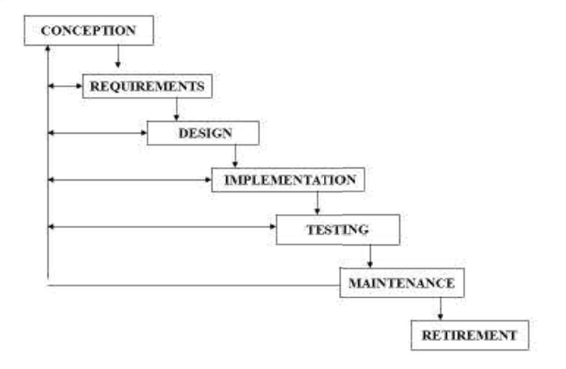

*Framework activities*: The framework for our project will begin with communication pertaining to planning the project. This phase will be followed by the modeling phase. Next, we will begin construction on our project, implementing code and working out any necessary kinks. We will complete our framework by concluding product deployment. During all aforementioned tasks, we will continuously perform risk management, track our timeline in our project, and continually remind one another of the overall completion and ensure to keep on target of said date.

|  |  |
| --- | --- |
| **Phases** | **Task Set** |
| Communication | Initialize project  Gather all necessary requirements |
| Planning | Estimating, scheduling, tracking |
| Modeling | Analysis, design |
| Construction | Code, test |
| Deployment |  |

* **4.2 Functional Decomposition**

*Task Breakdown:*

*Communication* **-**

Define Project Scope

Major Software Functions

Performance/Behavior Issues

Management And Technical Constraints

*Planning* **-**

Cost Estimation

Identify Resources Needed

Complete Project Time-Line And Milestones

Risk Assessment

*Design* **-**

Interface And Navigation Structure

Account Database Access And Management

Flight, Hotels, And Car Rentals Database Access And Management

Shopping Cart Functions

Billing And Credit Card

*Implementation* **-**

Build The User Interface And Navigation

Coding All Functionality

Testing And Verification

*Deployment* **-**

Upload The Completed Site To Server

Support Team Activated

Maintenance

* **4.3 Task Network**

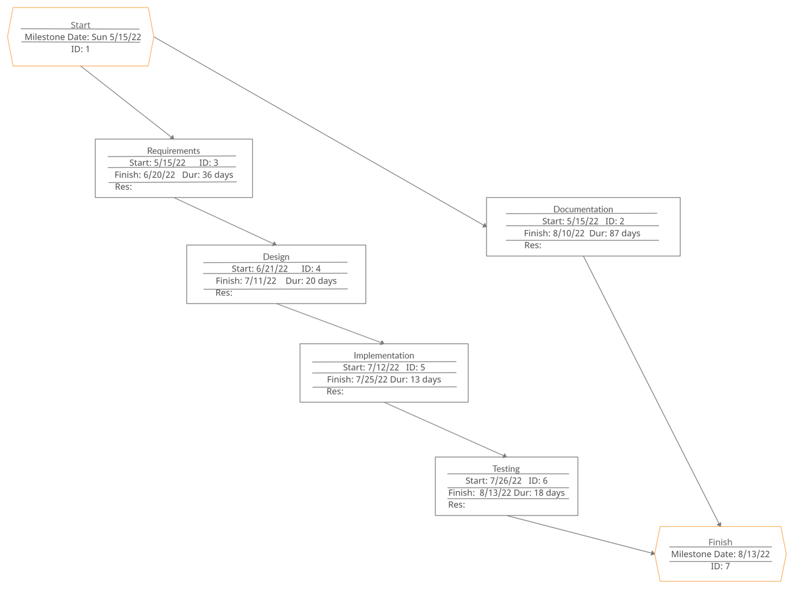

* **4.4 Timeline Chart**

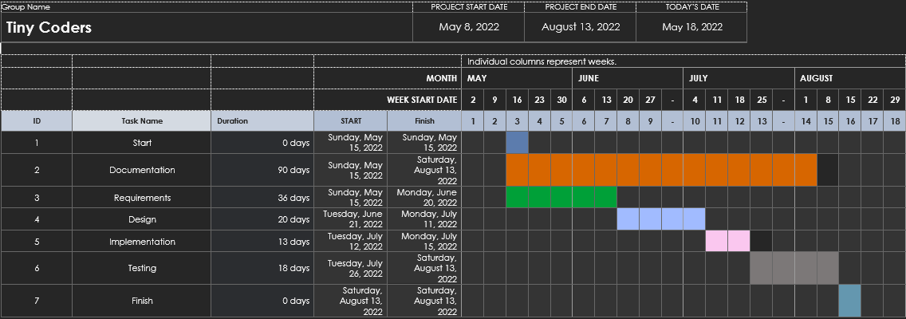

**5.0 Staff Organization**

* **5.1 Team Structure:**

Our group will be using and maintaining a democratic team approach to developing our project. This team structure was chosen to enable our team to be productive, reduce the strain of one individual, and ensure equal responsibility.

Role and Description

|  |  |
| --- | --- |
| **Role** | **Name** |
| **Project Manager** | Erika Valle-Baird, Madison Bilko |
| **Project Scheduling** | Mohammed Khoshkhoiyazdi, Collin Cavanaugh |
| **Project Estimation** | Erika Valle-Baird, Mohammed Khoshkhoiyazdi, Domeniko Kodra, Madison Bilko, Collin Cavanaugh |
| **Risk Mgmt.** | Erika Valle-Baird, Mohammed Khoshkhoiyazdi, Domeniko Kodra, Madison Bilko, Collin Cavanaugh |

* **5.2 Management Reporting & Communication**

|  |  |  |  |  |
| --- | --- | --- | --- | --- |
| **Communication Type** | **Method / Tool** | **Frequency/Schedule** | **Information** | **Participants / Responsible** |
| **Inter Communication** | | | | |
| Project Meetings | Discord | Weekly | Project status, issues, risks | Project Manager  Team |
| Sharing of project data | WhatsApp, GitHub | When available | Documentation/Reports | Project Manager  Team |
| Project Scheduling Meetings | Discord | Before milestones | Progress status | Project Scheduler |
| Final Project Meeting | Discord | Final Date | Presentations | Project Manager  Team |
| **Intra Communication** | | | | |
| Project Report | Power Point, Word Document | End Date | Project  -Demo  -Present | Project Manager  Team |